**Annual performance report for:** Wastecare Limited

## Permit Number: EPR/TP3200PR Year: 2022

This report is required under the Industrial Emissions Directive’s Article 55(2) requirements on reporting and public information on waste incineration plants and co-incineration plants, which require the operator to produce an annual report on the functioning and monitoring of the plant and make it available to the public.

# Introduction

|  |  |
| --- | --- |
| Name and address of plant | WasteCare Limited  East Kent Waste Recovery Facility Ramsgate Road  Sandwich Kent  CT13 9NJ |
| Description of waste input | Residual domestic and commercial & industrial waste, clinical waste |
| Operator contact details if members of the public have any questions | Helen Kellett 07795 400071  QHSE Director |

1. **Plant description**

Incineration of liquid and solids wastes in an incinerator with the capacity of 1.5T/hr, produced within the installation as well as imported wastes from other sites operating from discovery park and third parties.

1. **Summary of Plant Operation**

|  |  |
| --- | --- |
| Municipal waste received | 0 tonnes |
| Commercial and industrial waste received | 203.274 tonnes |
| Hazardous waste received | 1908.538 tonnes |
| Clinical waste received | 3160.422 tonnes |
| Other waste received (non haz) | 672.900 tonnes |
| Total waste received | 5741.860 tonnes |
| Total plant operational hours | 6696 hours |
| Total hours of “abnormal operation” (see  permit for definition) | 0 hours |
| Total quantity of incinerator bottom ash  (IBA) produced | 384.990 tonnes |
| Disposal or recovery route for IBA | Sent for disposal by Augean |
| Did any batches of IBA test as  hazardous? If yes, state quantity | 384.990 tonnes |
| Total quantity of air pollution control  (APC) residues produced | 232.720 tonnes |
| Disposal or recovery route for APC  Residues | Sent for disposal by Veolia |
| Total electricity generated for export to  the National Grid | 0 MWh |
| Thermal energy produced for export (e.g.  to hospital or district heating scheme) | 0 MWh |

1. **Summary of Plant Emissions**

## Summary of continuous emissions monitoring results for emissions to air

The following charts show the performance of the plant against its emission limit values (ELVs) for substances that are continuously monitored.

Line 1 - Hydrogen chloride

Line 1 – Sulphur dioxide

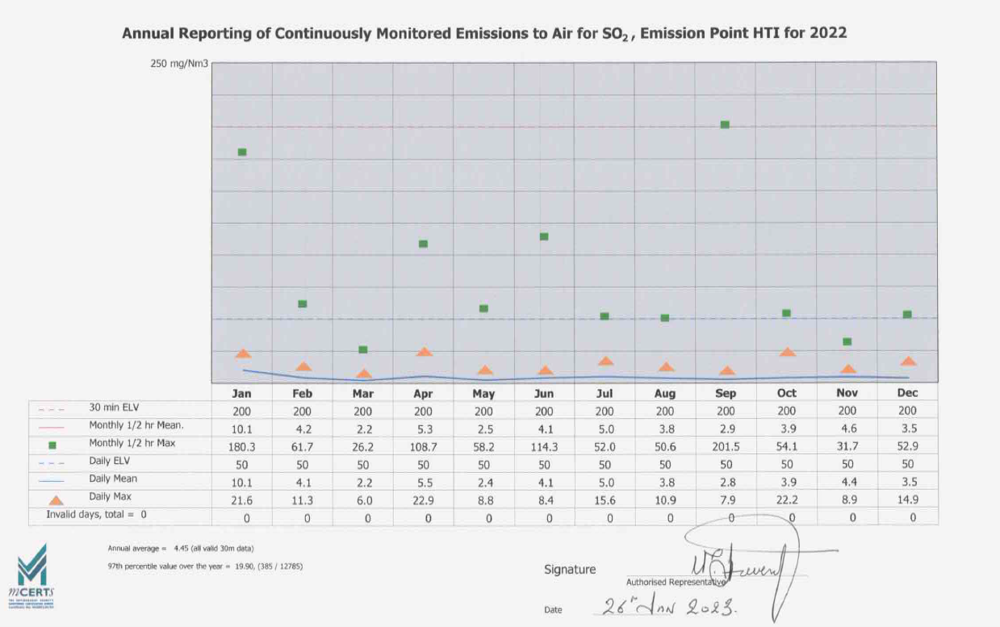

Line 1 – Oxides of nitrogen

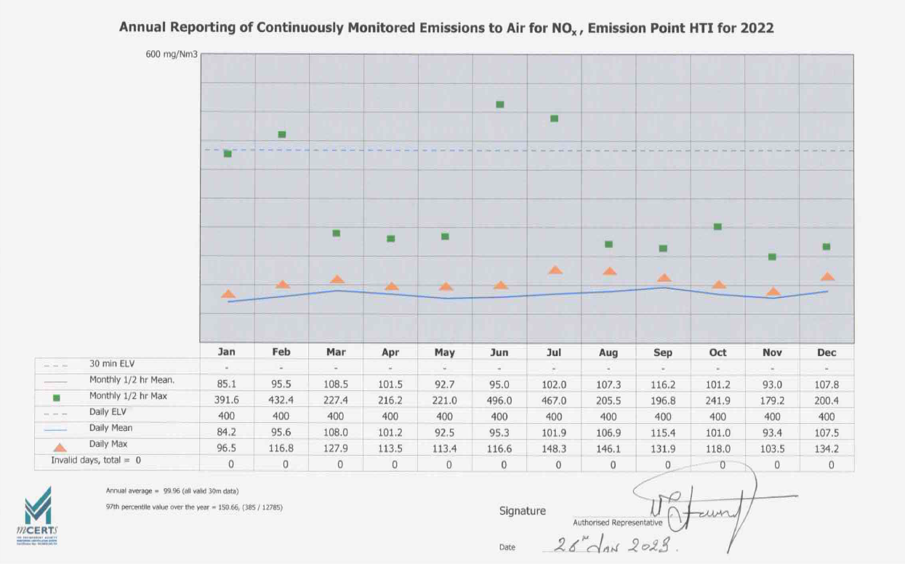

Line 1 – Total organic carbon

Line 1 – Particulates

Line 1 – Carbon monoxide

## Summary of periodic monitoring results for emissions to air

The table below shows the results of periodically monitored substances.

|  |  |  |  |
| --- | --- | --- | --- |
| **Substance** | **Emission limit value** | **Results** | |
| 09/06/2022 | 11/01/2023 |
| Mercury and its compounds | 0.05 mg/m3 | 0.001 mg/m3 | 0.0010mg/m3 |
| Cadmium & thallium and their compounds (total) | 0.05 mg/m3 | 0.0020 mg/m3 | 0.0009mg/m3 |
| Sb, As, Pb, Cr, Co, Cu, Mn, Ni and V and their compounds (total) | 0.5 mg/m3 | 0.15 mg/m3 | 0.028mg/m3 |
| Dioxins and furans (I- TEQ) | 0.1 ng/m3 | 0.11 ng/m3 | 0.16ng/m3 |
| Hydrogen Fluoride | 2 mg/m3 | 0.23 mg/m3 | 0.05mg/m3 |

## Summary of monitoring results for emissions to water

There are no emissions to water from the process [other than clean surface water].

# Summary of Permit Compliance

## Summary of any notifications or non-compliances under the permit

|  |  |  |  |
| --- | --- | --- | --- |
| **Date** | **Summary of notification or non-**  **compliance** | **Reason** | **Measures taken to prevent reoccurrence** |
| 06/02/2022 | 22.5 mg/Nm3-C over a 30-minute period (30% uncertainty subtracted respectively) | The waste feeds being processed at the time of the incident were investigated.  The low and high CV liquid streams were selected at the time of the incident. Both high CV and Low CV feeds were deselected as soon as unstable kiln conditions were noticed.  Both liquid streams were only re-selected and introduced into the kiln once the emissions had returned to a stable condition.  The high CV and low CV solvent blends are of a homogenous nature and had remained unchanged throughout the shift and previous shifts so were not considered to have contributed to the breach.  The RAM feed was being used at the time of the incident, but it was not considered to be the cause of the TOC spike since as it was the same material processed both before and after the incident without further issues.  Sludge was being processed at the time of the incident, but it was not considered to be the cause of the TOC spike since it was processed both before and after the incident without further issues.  Blended skips were being processed at the time of the incident. The blended skips were comprised of a mixture of bagged clinical waste and sealed clinical waste bins. The contents of clinical waste are difficult to check due sealed nature of these waste streams.  A TOC spike had occurred whilst processing clinical waste. It appears likely that within a sealed package of clinical waste highly calorific and volatile materials were introduced into the kiln. Following the TOC spike, the kiln rotation was stopped to prevent the waste from turning over and burning, this is standard practise for high emissions encountered within the same 30-minute period. | All waste streams, solid and liquid, to the incinerator were ceased and not resumed until the emission profile had returned to a stable and steady state. |
| 06/03/2022 | 117 mg/Nm3 TPM over a 30-minute period (30% uncertainty subtracted respectively) | The TPM exceedance was due to a plant trip; the trip was caused by a faulty communication switch on the dump stack.  When the dump stack is closed and the switch is made, it sends a signal to the PLC allowing the plant to run, when the signal is broken due to the dump stack being opened it sends a signal to the PLC which in turn shuts the plant down, or, if during start up, the switch is not made, it prevents the plant from starting.  Further investigation found that the dump stack switch mounting bracket was loose, possibly caused by the recent very high winds.  When the plant trips it automatically puts the APC filters into by-pass; this function is built into the plant logic to protect the filter bags from heat damage.  When the filters are by-passed, a small amount of neat sodium bicarbonate is picked up in the by-pass ductwork and is carried over the dust probe. | New dump stack switch supporting bracket fitted. |
| 06/03/2022 | 44.7 mg/Nm3 TPM over a 30-minute period (30% uncertainty subtracted respectively) | This TPM exceedance was directly caused by events which occurred following the initial TPM exceedance within the same hour.  Whilst the operators were pre-occupied in making the plant safe following the plant trip, unbeknown to them, something in a clinical waste tub had adversely reacted within the base auger chamber; this occasionally occurs, but when the plant is on-line the reacting material can be quickly fed into the kiln preventing escalation.  Unfortunately, with the plant off-line the reacting material within the auger chamber caught fire, water sprays are built into the system to combat such events, these sprays were manually activated.  The operators decided to turn on the ID fan at the back end of the system to draw the smoke away from the auger chamber to enable for better viewing.  All waste feeding had ceased, however, the required burn out time to de-activate the CEM had not been reached.  The same conditions occurred as the first TPM exceedance in the same hour; with the filters in by-pass, neat residue sodium bicarbonate was picked up in the by-pass ductwork and drawn over the dust hunter. | This was a rare and unfortunate combination of events; the operators made the correct decision to contain and extinguish the fire to prevent further escalation.  As per the previous measure for the TPM exceedance in the same hour; new dump stack switch bracket fitted on the dump stack lid. |
| 11/03/2022 | 43.1 mg/Nm3-C over a 30-minute period (30% uncertainty subtracted respectively) | At the time of the TOC exceedance, the main solid feed system (bin feed) was un-operational, permissive temperatures were being maintained using natural gas and waste solvents.  Waste was being fed into the kiln via the solvent lances, sludge, and ram.  The solvents and sludge were being continually fed into the kiln at a set rate; material through the ram was being fed at random intervals when the kiln conditions were stable (high oxygen).  Desk top assessments are carried out on ram feed material, the results of these assessments denote the volume, or weight that’s considered safe to process in terms of reactivity and the emissions generated.  As this exceedance occurred immediately after a ram feed cycle, it was very evident that this was the cause of the TOC exceedance.  The material was being fed into the kiln via the ram at the rate as identified during the assessment, approx. 90% of the available material of this type of had been processed with no issues.  The container which caused the exceedance was labelled in the same way as was the previous processed containers, the weight was also the same.  It can only be assumed that the composition of this particular container was not as described on the label and was not typical of the batch. | Reduce the volume / weight of the remaining 10% of the containers by 50% from the original assessment to function as a safety buffer. |
| 12/03/2022 | 38.9 mg/Nm3-C over a 30-minute period (30% uncertainty subtracted respectively) | At the time of the TOC exceedance, the main solid feed system (bin feed) was un-operational, permissive temperatures were being maintained using natural gas and waste solvents.  Waste was being fed into the kiln via the solvent lances, sludge, and ram.  The solvents and sludge were being continually fed into the kiln at a set rate; material through the ram was being fed at random intervals when the kiln conditions were stable (high oxygen).  Due to a recent TOC exceedance, where it was identified that a possible cause of the exceedance was an incorrectly packed / labelled container, the remaining ram feed material was being reduced in volume by 50%.  Whilst this re-packing was being undertaken, clinical waste tubs were being fed into the kiln via the ram feed as single items.  When clinical waste is fed int the kiln via the bin lift (and augers), it is shredded to produce a homogenous mix of material prior to it entering the kiln, this in turn allows for an even burn as far as practicable.  As this incident occurred immediately after a ram feed cycle, it was very evident that an unidentified object within the clinical waste container was the cause of the TOC exceedance. | Stopped feeding this batch of clinical waste and switched to a different batch until the bin feed system was repaired. |
| 30/03/2022 | 190.3 mg/Nm3 TPM over a 30-minute period (30% uncertainty subtracted respectively)  97.8 mg/Nm3 TPM over a 30-minute period (30% uncertainty subtracted respectively) | This HCL exceedance was caused by a plant trip; the cause of the trip was a fault on the boiler recirculation pump.  The plant is designed to trip if this pump fails, if the pump is not running there is a high risk that the boiler will overheat.  When the plant trips it automatically puts the APC filters into by-pass; this function is built into the plant logic to protect the filter bags from heat damage. When the filters are by-passed, there is no abatement being applied to the flue gases. | Faulty electrical connection on the boiler recirculation pump re-wired and repaired.  Feed water pressure switch replaced |
| 02/04/2022 | 35.1mg/Nm3-C over a 30-minute period (30% uncertainty subtracted respectively) | Incineration of clinical waste can generate substantial amounts of slag build up at both the front and back end of the kiln; this slag build up can mostly be controlled by suspending the solid inputs and raising the kiln temperatures, this additional heat allows for the slag to flow more freely (known locally as a kiln de-slag).  It should be noted that raising the kiln temperature above normal operating temperatures for pro-longed periods can have a detrimental effect on the kiln refractory, there has to be a balance between risk verses gain, this decision is made dynamically during discussions between the operators and management.  This “de-slag” works most of the time, unfortunately not all of the time, in this instance, following a large volume of clinical waste processing, a lot of slag had started to form at the front end of the kiln.  During normal operation, the kiln rotates at approx. 0.5 revolutions p/m; this is to allow the material being incinerated to tumble and ensure complete destruction.  At the time of the TOC exceedance, the heavy slag build up at the front end had jammed the kiln, this situation can become very harmful to the kiln shell due to excessive heat being directed to one area of the shell.  There is a function on the MCC panel to operate the kiln rotation in manual (kiln rotation is normally in auto), the operators made the decision to try and turn the kiln using this manual function to help free up the jammed kiln.  Unfortunately, there is no kiln rotation speed control when using the manual function, when the kiln became free and started to rotate, it did so at full speed (approx. 2 rpm); this in turn caused the waste / slag within the kiln to tumble too quickly causing the TOC exceedance. | Kiln shutdown and cooled to allow for entry, slag build up at the front end of the kiln manually dug out and removed. |
| 19/04/2022 | 93.7mg/Nm3 TPM over a 30-minute period (30% uncertainty subtracted respectively) | This TPM exceedance was caused by a plant trip; the trip was initiated by the steam pressure safety valves lifting, this in turn bounced the boiler level probes which read as low low boiler level.  The plant is designed to trip if any one of the two boiler level probes read as low low level.  When the plant trips it automatically puts the APC filters into by-pass; this function is built into the plant logic to protect the filter bags from heat damage. When the filters are by-passed, a small amount of neat sodium bicarbonate is picked up in the by-pass ductwork and is carried over the dust probe. | Maintain the HTI steam output pressure to below 9 bar until the steam safety valves can be checked for correct operation. |
| 22/04/2022 | 57.7 mg/Nm3 TPM over a 30-minute period (30% uncertainty subtracted respectively) | On the 22nd April 2022 between the hours of 15:00 and 15:29, the ID fan which draws the waste gases through the heat exchanger and filter housings tripped; as part of the HTI built in safety system philosophy, when this fan fails it causes the plant to shut down.  When the plant shuts down, it automatically diverts the waste gases away from the filter housings via a bypass, this is designed to protect the filter bags from heat damage.  When the filters are in by-pass, a residue of sodium bicarbonate can be picked up in the by-pass ductwork and carried over the dust hunter; this action can result in a TPM exceedance.  On investigation, it was found that the ID fan had tripped due to an earth fault, however, despite during extensive testing the site engineer could not diagnose why this fault occurred. | Have the pump motor checked out by a specialist electrical engineer.  Unfortunately, the engineer couldn’t find a definitive reason that would cause the motor to trip.  Action: Purchase a new motor and fit ASAP. |
| 01/05/2022 | 49.2 mg/Nm3 TPM over a 30-minute period (30% uncertainty subtracted respectively) | On the 1st May 2022 between the hours of 15:00 and 15:29, the operators were carrying de-slagging operations; this process involves gradually raising the kiln operating temperatures until the slag build up at the exit end of the kiln starts to melt and subsequently runs into the  quench bath.  Occasionally, large deposits of slag form on the kiln exit dam, this build up can be very difficult to melt, it can also be very difficult to control the rate at which the slag falls into the quench bath.  At the time of the incident, whilst de-slagging, a large volume of slag fell off the exit dam wall into the quench bath; this event caused a large amount of steam to be generated which was picked up in the gas path and carried through to the back-end temperature probe TT003.  TT003 temperature probe measures the flue gas temperature prior to it going through the filters and is designed to trip the plant if the temperature goes above 210 degrees; this is the maximum temperature the flue gas can be before it can cause damage to the filter bags.  When the plant shuts down, it automatically diverts the waste gases away from the filter housings via a bypass, this is designed to protect the filter bags from heat damage.  When the filters are in by-pass, a residue of sodium bicarbonate can be picked up in the by-pass ductwork and carried over the dust hunter; this action can result in a TPM exceedance. | At the rear end of the kiln, between the fixed and the rotating part of the shell, there is a Webco seal; this seal has 3 functions:  1. It helps maintain a negative pressure within the kiln.  2. It creates a seal that prevents any gases within the kiln from escaping.  3. It prevents tramped air from entering the kiln which acts as a cooling medium.  The Webco seal is becoming worn and is allowing tramped air to enter the kiln; this air can act as a cooling medium which cools the slag too quickly, given the right conditions this can cause large deposits of slag to form.  The site is currently looking into purchasing and renewing this seal at the next planned shutdown. |
| 06/05/2022 | 84.3mg/Nm3 HCl over a 30-minute period (40% uncertainty subtracted respectively) | The waste feeds being processed at the time of the incident were investigated.  No HCV or LCV liquids, and no RAM feed material was being processed at the time of the incident.  Sludge was not being processed at the time of the exceedance due to the inlet port into the kiln being blocked.  Blended skips were being processed at the time of the incident. The blended skips comprised of a mixture of bagged clinical waste and sealed clinical waste bins. The contents of clinical waste bins are difficult to check due to the hazardous nature of these waste streams.  A HCL spike had occurred whilst processing clinical waste, (blended skip No 7). It appears likely that within a sealed package of clinical waste, an amount of halogenated material was introduced into the kiln.  Following the HCL spike, the abatement system was increased to 100% and the kiln rotation was stopped to prevent the waste from turning over and burning; this is standard practice for high emissions encountered within the same 30-minute period. | Blended skips No7 taken out of the process line and re-blended |
| 23/06/2022 | 09:00-09:29 50.0mg/Nm3 TPM over a 30-minute period (30% uncertainty subtracted respectively)  09:30-09:59 2035.1mg/Nm3 TPM over a 30-minute period (30% uncertainty subtracted respectively  Daily average 99.82mg/Nm3 TPM | The HTI APC system consists of 2 bags house filters (filter 1 and filter 2).  Combustion gases first pass through filter1 1, then continue through filter 2, when the filter bags start to block up, or are compromised, the differential pressure measured at both the inlet and outlet sides of the filter starts to drift; when this pressure difference goes outside of the pre-set ranges it automatically takes the filter off-line and puts it into by-pass.  At the time of the incident, the differential pressures in filter 2 went out of range automatically putting it into by-pass; this reduced the filtration of the gases by 50%.  Unbeknown to the operators, some of the bags in filter 1 were compromised, this condition is difficult to detect in filter1 as any particulate carry over is captured in filter 2.  At the time of the incident, when filter 2 came off-line, filter 1 (due to the bags being compromised) was unable to reduce the particulates sufficiently enough, resulting in an exceedance.  The timing of the exceedance went into 2 half hour periods, so although the data is showing 2 TPM exceedances, it was actually the same incident.  Immediately after the exceedance the plant was taken off-line and shutdown to further investigate both filter houses; as a result of this the TPM daily average limit was exceeded due to a lack of hours in the day to correct the averages.  Having looked further into the data and the substantial number, it is doubtful that the daily average would have been compliant even if the plant was on-line for the 24 hours. | Take the plant off-line and inspect the filter bags in both filters. |
| 28/06/2022 | 25.48 mg/Nm3 TOC over a 30-minute period (30% uncertainty subtracted respectively) | On the 28th of June 2022 between the hours of 16:00 and 16:29, the operators were carrying de-slagging operations; this process involves gradually raising the kiln operating temperatures until the slag build up at the exit end of the kiln starts to melt and subsequently runs into the quench bath.  Occasionally, large deposits of slag form on the kiln exit dam, this build up can be very difficult to melt, it can also be difficult to control the rate at which the slag falls into the quench bath.  At the time of the incident, whilst de-slagging, a large volume of slag fell off the exit dam wall into the quench bath; the event caused a large amount of gas and steam to be generated; this was picked up in the gas path resulting in a TOC exceedance.  The accelerated formation of slag on the exit end of the dam could be attributed to a worn seal between the fixed and the moving part of the kiln; this worn seal encourages tramped air to be drawn into the kiln which acts as a cooling medium encouraging the molten slag to solidify on the dam and back wall. | De-slagging operation ceased until the kiln conditions returned to normal.  Order a new seal for the rear end of the kiln and fit. |
| 18/07/2022 | 25.7mg/Nm3-C over a 30-minute period (30% uncertainty subtracted respectively) | The waste feeds being processed at the time of the incident were investigated.  The low and high CV liquid streams were selected at the time of the incident. Both high CV and Low CV feeds were deselected as soon as unstable kiln conditions were noticed.  Both liquid streams were only re-selected and introduced into the kiln once the emissions had returned to a stable condition.  The high CV and low CV solvent blends are of a homogenous nature and had remained unchanged throughout the shift and previous shifts so were not considered to have contributed to the breach.  The RAM feed device was not in use at the time of the incident and so could not have contributed to the exceedance.  Sludge was being processed at the time of the incident, but it was not considered to be the cause of the TOC spike since it was processed both before and after the incident without further issues.  Blended skips were being processed at the time of the incident. The blended skips were comprised of a mixture of bagged clinical waste and sealed clinical waste bins. The contents of clinical waste are difficult to check due sealed nature of these waste streams.  A TOC spike had occurred whilst processing clinical waste. It appears likely that within a sealed package of clinical waste highly calorific and volatile materials were introduced into the kiln. Following the TOC spike, the kiln rotation was stopped to prevent the waste from turning over and burning, this is standard practise for high emissions encountered within the same 30-minute period. | Site chemist to re-visit the skipped material to check for any obvious signs of incorrectly blended material. |
| 20/08/2022 | 37.6 mg/Nm3-C over a 30-minute period (30% uncertainty subtracted respectively) | The waste feeds being processed at the time of the incident were investigated.  The low and high CV liquid streams were selected at the time of the incident. Both high CV and Low CV feeds were deselected as soon as unstable kiln conditions were noticed.  Both liquid streams were only re-selected and introduced into the kiln once the emissions had returned to a stable condition.  The high CV and low CV solvent blends are of a homogenous nature and had remained unchanged throughout the shift and previous shifts so were not considered to have contributed to the breach.  Sludge was being processed at the time of the incident, but it was not considered to be the cause of the TOC spike since it was processed both before and after the incident without further issues.  Blended skips were being processed at the time of the incident; these skips mainly comprised of clinical waste; the same blend of material within the skips was being processed prior to, and following the exceedance.  The RAM feed device was in use at the time of the incident, and it is most likely that this caused the exceedance.  At the time of the incident, alcohol-based hand gels were being processed at a rate of 8kg per cycle, this weight of unchanged material had been processed for approx. 3 hours prior to the exceedance.  It is concluded that a rogue batch of the hand sanitisers which contained more alcohol than it stated on the label led to the TOC exceedance. | Reduce the weight of hand sanitisers from 8Kg to 6Kg when being processed via the RAM feeder |
| 20/08/2022 | 72.59 mg/Nm3-C over a 30-minute period (30% uncertainty subtracted respectively) | The waste feeds being processed at the time of the incident were investigated.  The low and high CV liquid streams were selected at the time of the incident. Both high CV and Low CV feeds were deselected as soon as unstable kiln conditions were noticed.  Both liquid streams were only re-selected and introduced into the kiln once the emissions had returned to a stable condition.  The high CV and low CV solvent blends are of a homogenous nature and had remained unchanged throughout the shift and previous shifts so were not considered to have contributed to the breach.  Sludge was being processed at the time of the incident, but it was not considered to be the cause of the TOC spike since it was processed both before and after the incident without further issues.  The RAM feed device was in use at the time of the incident and could have contributed to the exceedance.  Blended skips were being processed at the time of the incident; these skips were mainly comprised of clinical waste.  At the time of the incident, it appears that some volatile material within the clinical waste tubs ignited whilst it was being shredded within the base auger; this ignition caused the material within the drop chamber to catch fire; this happens occasionally and is exacerbated by heat transfer through the auger.  The drop chamber has water spray attachments fitted as standard to help suppress such events; it is standard procedure to quickly feed the material into the kiln to help remove all combustible material from the drop chamber.  Whilst this damp material was being fed into the kiln it coincided with a RAM feed cycle; both the RAM and the damp material in the auger suppressed the available oxygen in the kiln causing a TOC exceedance. | Ensure that the kin conditions are favourable before using the RAM feed. |
| 18/09/2022 | 201.5 mg/Nm3 Sulphur Dioxide over a 30-minute period (20% uncertainty subtracted respectively) | The waste feeds being processed at the time of the incident were investigated.  The low and high CV liquid streams were selected at the time of the incident. Both high CV and Low CV feeds were deselected as soon as unstable kiln conditions were noticed.  Both liquid streams were only re-selected and introduced into the kiln once the emissions had returned to a stable condition.  The high CV and low CV solvent blends are of a homogenous nature and had remained unchanged throughout the shift and previous shifts so were not considered to have contributed to the breach.  Sludge was being processed at the time of the incident, but it was not considered to be the cause of the SO2 spike since it was processed both before and after the incident without further issues.  Blended skips were being processed at the time of the incident; these skips mainly comprised of clinical and pharma waste; the same blend of material within the skips was being processed prior to and following the exceedance.  The RAM feed device was in use at the time of the incident, and it is most likely that this caused the exceedance.  At the time of the incident, pails of sulphuric acid were being processed at a rate of 4kg per cycle, this weight of unchanged material had been processed for approx. 2 hours prior to the exceedance.  It is concluded that a rogue batch of sulphuric acid was more concentrated than it stated on the label which led to the SO2 exceedance. | Reduce the weight of material being processed from 4 kg to 3 Kg. |
| 10/10/2022 | 52.7 mg/Nm3-C over a 30-minute period (30% uncertainty subtracted respectively) | The waste feeds being processed at the time of the incident were investigated.  The low and high CV liquid streams were selected at the time of the incident. Both high CV and Low CV feeds were deselected as soon as unstable kiln conditions were noticed.  Both liquid streams were only re-selected and introduced into the kiln once the emissions had returned to a stable condition.  The high CV and low CV solvent blends are of a homogenous nature and had remained unchanged throughout the shift and previous shifts so were not considered to have contributed to the breach.  Sludge was being processed at the time of the incident, but it was not considered to be the cause of the TOC spike since it was processed both before and after the incident without further issues.  Blended skips were being processed at the time of the incident; these skips mainly comprised of clinical and pharma waste; the same blend of material within the skips was being processed prior to and following the exceedance.  The RAM feed device was in use at the time of the incident, and it is most likely that this caused the exceedance.  At the time of the incident, alcohol-based hand gels were being processed at a rate of 6kg per cycle, this weight of unchanged material had been processed for approx. 5 hours prior to the exceedance.  It is concluded that a rogue batch of the hand sanitisers which contained more alcohol than it stated on the label led to the TOC exceedance. | Reduce the weight of hand sanitisers from 6Kg to 5Kg when being processed via the RAM feeder |
| 12/10/2022 | 562.5mg/Nm3 TPM over a 30-minute period (30% uncertainty subtracted respectively)  12.52 mg/Nm3 TPM Daily average. | On the 12th Oct 2022 at approx. 14:30, the plant tripped; when the plant shuts down, it automatically diverts the waste gases away from the filter housings via a bypass, this is designed to protect the filter bags from heat damage.  When the filters are in by-pass, a residue of sodium bicarbonate can be picked up in the by-pass ductwork and carried over the dust hunter; this action can result in a TPM exceedance.  On investigation, it was found that the boiler level was reading low low, when this happens the plant automatically shuts down to protect the boiler against heat damage.  Upon further investigation, it was discovered that the device which controls the water level in the reverse osmosis water plant that feeds the HTI boiler was faulty: this restricted the flow of water into the boiler causing it to go low low. | Replace the faulty water level device in the reverse osmosis plant. |
| 03/11/2022 | 55.4 mg/Nm3 TPM over a 30-minute period (30% uncertainty subtracted respectively) | On the 3rd Nov 2022 at approx. 21:30 hrs, the plant tripped; when the plant shuts down, it automatically diverts the waste gases away from the filter housings via a bypass, this is designed to protect the filter bags from heat damage.  When the filters are in by-pass, a residue of sodium bicarbonate can be picked up in the by-pass ductwork and carried over the dust hunter; this action can result in a TPM exceedance.  At the time of the exceedance, the boiler level transmitter went into fault causing it to read low low, when this happens the plant automatically shuts down to protect the boiler against heat damage.  On further investigation, the boiler level transmitter was found to contain a small amount of viscous rusty water (this should normally be clean water), this viscous rusty water caused the level transmitter to go into fault and read incorrectly.  The rusty water may have been dragged up the system when the boiler was starved of water (previous exceedance). | Take the plant off-line, remove, clean, and replace the dirty level transmitter.  During the next planned shutdown (21/11/2022), jet wash and clean the boiler, tubes, and associated pipework. |
| 05/12/2022 | 116.3mg/Nm3 HCl over a 30-minute period (40% uncertainty subtracted respectively) | On the morning of the 5th Dec 2022, high HCL levels were being encountered, the higher than average readings appeared to be coming from the solid waste being fed through the Komar auger.  In an attempt to lower the levels of HCL, the blended waste in the feed stock was re-visited and the feed rate was reduced whilst simultaneously increasing the APC additions to a maximum.  The combination of the above firstly appeared to lower the HCL levels, but unfortunately at the time specified in the Part A of this document, the plant experienced a HCL exceedance.  On further investigation it was discovered that the delivery auger which feeds the sodium bicarbonate into filter 1 had failed meaning that the emissions abatement was relying solely on filter 2. | Remove and replace filter 1 auger with a new unit and ensure correct operation. |
| 20/01/2022  02/03/2022  08/06/2022 | **Dioxins** (limit 0.1ng/m3)  0.420ng/m3  0.130ng/m3  0.110ng/m3 | 20/01/2022  Activated carbon particles are injected into the flue gas stream ahead of the particulate APC by means of a screw auger. The carbon particles adsorb pollutants on their surface and then the carbon particles are themselves captured in the particulate APC. Activated carbon has a large surface-area-to-volume ratio and is extremely effective at adsorbing a wide range of vapour-phase organic-carbon compounds, and also some other vapours (like mercury) that are otherwise hard to control.  Maximum effective use of the technique requires optimization of the rate of injection of activated carbon, effectiveness is also dependant on the carbon particles being of a dry state.  Following the previous dioxin failure, the carbon bag was again checked for moisture content, this proved to be dry.  The mechanical device that feeds the carbon into the gas path was also checked; within this device is an auger screw which feeds the carbon into its discharge port, this auger was found to be sheared.  It is our conclusion that the auger became weakened whilst trying to move the previous damp and semi-solidified carbon, the flaw in the auger which eventually led to its failure would not have been detected when it was checked previously following the initial dioxin failure.  02/03/2022  Following the previous dioxin failure, the carbon bag was again checked for moisture content, this proved to be dry.  The mechanical device that feeds the carbon into the gas path was also checked; this was found to be in good order and working correctly.  The current carbon dosing system remains the same design as built and commissioned back in 1998; it was designed to inject activated carbon into only one of the two bag house filters (filter 1); this has proven to be far from ideal as if filter 1 comes off-line the plant is forced to stop processing as the heavy metals and dioxins cannot be filtered out.  Following investigations, we have concluded that the current carbon dosing system is worn and inadequate for the type of waste being processed.  08/06/2022  Following the previous dioxin failure, and as per the actions from this previous failure, the carbon dosing system was re-designed, fabricated and installed; this new system will now deliver carbon to both filter 1 and filter 2.  As this is a completely new design, it was difficult to gauge the exact settings of the regulating valves, too far open would deliver more carbon than is required, and too far closed would not dose the carbon sufficiently.  As can be seen from the test failure results (0.11 against 0.10), the valves were set slightly incorrectly which restricted the flow of carbon into the gas path resulting in a failed test. | 20/01/2022  Replace the defective screw feed auger.  02/03/2022  Re-design and install a more effective carbon dosing system that injects activated carbon into both filter 1 and filter 2.  08/06/2022  Make the necessary adjustments to the new valves so that the correct amount of carbon is being delivered.  Arrange for a dioxin re-test, and a second test to confirm accuracy. |

* 1. **Summary of any complaints received and actions to taken to resolve them.**

|  |  |  |  |
| --- | --- | --- | --- |
| **Date of complaint** | **Summary of complaint** | **Reason for complaint including whether substantiated by the**  **operator or the EA** | **If substantiated, measures to prevent reoccurrence** |
|  | None |  |  |

1. **Summary of plant improvements**

|  |
| --- |
| **Summary of any permit improvement conditions that have been completed within the year and the resulting environmental benefits.** |
| None |
| **Summary of any changes to the plant or operating techniques which required a variation to the permit and a summary of the resulting environmental impact.** |
| None |
| **Summary of any other improvements made to the plant or planned to be made and a summary of the resulting environmental benefits.** |
| **Primary Combustion Chamber**.  Complete renewal of the Primary Combustion Chamber (PCC) refractory lining including new steelwork to the kiln exit dam.  **Rotary Kiln External Seal.**  Renewal of the rear kiln seal; this seal helps prevent tramp air from being drawn into the heated chamber, tramp air can have a cooling affect on the molten slag.  Cooled slag can build up on the exit dam and back wall; this slag can become very large and heavy, when it falls off into the quench bath it can generate large volumes of TOC which can lead to a permit exceedance.  **Soot blowers change of steam to air.**  The soot blowers are designed to clean any solid deposits off the heat exchanger tubes; these deposits are carried over in the gas path and build up on the tubes causing them to become insulated and inefficient.  When the plant was designed, steam was a by-product of little value to the business, however, steam is now a precious source of energy which is currently being used to produce electricity which in turn powers the plant.  Some of the soot blowers (the most regular used), have been modified to use compressed air in place of steam, this frees up the steam for electricity generation.  As this has proved successful, it is intended to change all the remaining soot blowers over from steam to air.  **Modifications to the steam pipework supplying the electrical generator (Heliex)**  When the plant was designed, steam was exported to Discovery Park (then Pfizer); this steam left the plant via 200mm pipework and joined the steam ring main which supplied the Park with heating and cooling. The Incinerator also required steam to heat the boiler feed water and domestic heating; this steam then came back into the incinerator building via 200mm pipework back tracking the same pipework that it was sent out on (basically a big loop approx. 150 metres long).  This loop caused a drop in steam pressure to the Heliex making it less efficient.  Modifications were carried out on the steam pipework to reduce the distance which the steam had to travel to the Heliex making it more efficient in electrical generation.  The steam being used for domestic heating in the incinerator building has been de-coupled, electricity is now being used for domestic purposes within the building; all generated steam is now being sent to the Heliex for electrical generation.  **Modifications to the carbon dosing system.**  Activated carbon is injected into the abatement system and is used to remove heavy metals and dioxins from the gas path following the incineration process.  The abatement system consists of 2 filter housings (filter 1 and filter 2); this system was originally designed to inject carbon into filter 1 only.  Due to a change in the dynamics of the waste being incinerated, the carbon dosing system has proved to be inadequate, this has been confirmed by consecutive failures of metals and dioxin testing.  The carbon dosing mechanism has now been modified to deliver activated carbon to both filter 1 and filter 2; the new mechanism also includes finer adjustment capabilities and viewing ports to observe the carbon being dosed. |